**学 号：201814600205**





**2019-2020春季学期**

**计算机原理实验报告**

**作业题目：超前进位加法器的设计**

**学生姓名：马昕**

**专业班级：18计科2班**

**学 院：人工智能学院**

**任课教师：于复兴 副教授**

**2020年6月30日**项目基本信息

|  |  |
| --- | --- |
| 项目概述 | 本程序使用python语言开发，根据四位超前进位加法器改进而来，能够根据输入的两个加数，模拟进位等操作，并且能够显示出进位等中间过程，从而让使用者更加方便的学习超前进位加法器的原理以及结构。  使用者可以自己选择加数a和加数b，点击开始计算之后，将自动显示进位情况，并且显示出传递进位、本地进位的数值，最后将计算结果显示在屏幕上。  程序使用python语言开发，UI设计采用pyQT5来实现，对图片等资源文件进行了二进制转化，同时使用pyinstaller打包成exe可执行文件，并且预留了程序接口，能够快捷方便的将本程序嵌入到其他程序中。 |

# 1系统需求分析

## 1.1 功能需求分析

1. 输入数据：根据复选框选择两个加数的每一位。
2. 计算进位：依据加数计算是否需要进位。
3. 计算传递进位：计算并显示传递进位。
4. 计算本地进位：计算并显示本地进位。
5. 结果显示：在屏幕中显示出两数加和的结果。

## 1.2系统总体结构设计

超前进位加法器的实现一共包含以下几个模块:

1. 输入：根据复选框选择两个加数a，b的每一位。
2. 计算：根据输入的a，b的值计算进位信息。
3. 显示：将计算的中间结果以及最终结果显示出来。

根据需求分析的结果,总体结构如图2-1所示。

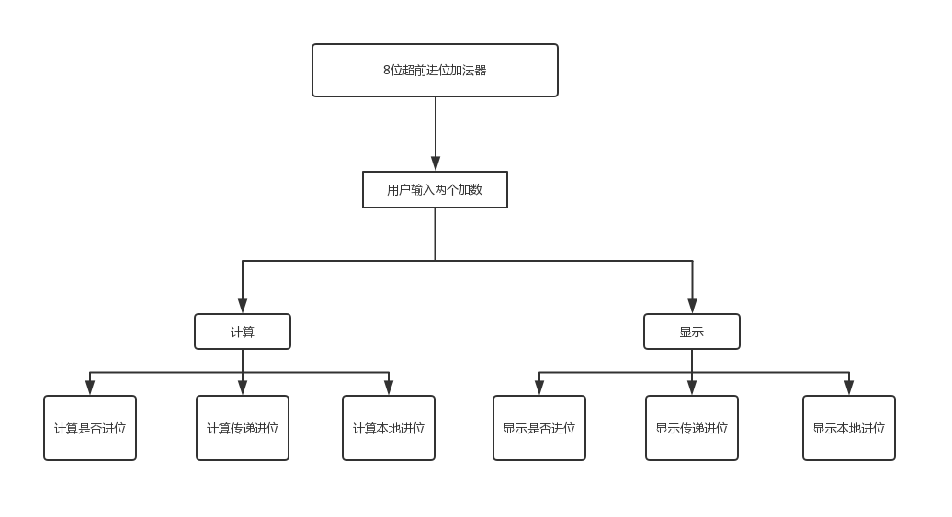

图2.1系统总体结构

# 2详细设计

## 2.1 数据结构设计

1. 类的设计

**表3-1 Stu类成员列表**

|  |
| --- |
| MyWindow类 |
| ui |
| is_check() |
| progressive_calculate() |
| local_calculate() |
| carry_calculate() |
| res_calculate() |

（2）系统包含的类库

import untitled UI界面模块

import sys 系统相关信息模块

from PyQt5.QtCore import Qt pyqt模块

from PyQt5.QtWidgets import QApplication, QMainWindow pyqt主界面模块

1. 各个变量的定义和作用

a,b:加数，有用户定义

p:传递进位

g：本地进位

C:是否进位

S：计算结果

## 2.2系统函数的组成、功能、参数说明、相互调用关系

**主函数 if __name__ == "__main__":**

初始化UI界面，创建UI对象，创建对象时即完成pyQT的槽函数以及信号函数的绑定，然后使用 show.show()显示UI界面，并且绑定程序结束按钮为界面右上角的关闭选项栏

**类构造函数 def __init__(self)：**

这是一个用于初始化类的函数，在创建函数对象的时候就会自动执行本函数，函数首先获取ui界面句柄，即拿到所有的控件，然后启动控件操作，最后为“计算结果”按钮绑定事件函数。

**按钮点击事件函数 def success_click_button(self)：**

这是一个无参函数，绑定在“计算结果”按钮上，当点击按钮时，会执行本函数，实现相关的计算依据以及数据展示。

**复选框判断函数 def is_chick(self)：**

这是一个无参函数，主要功能是判断复选框的选择情况，用于获取用户选择的两个加数。

**计算传递进位函数def progressive_calculate(self):**

本函数实现对传递进位的计算，并且将计算结果传入UI界面的复选框中。

**计算本地进位函数def local_calculate(self):**

本函数实现对本地进位的计算，并且将计算结果传入UI界面的复选框中。

**计算是否进位函数def carry_calculate(self):**

本函数实现判断是否进位，并且将计算结果传入UI界面的复选框中。

**计算结果函数def res_calculate(self):**

这个函数的功能是计算最终的相加结果，并显示在UI界面的文本框中。

# 3设计测试流程

1. 进入系统，显示本系统UI界面。如图3.1所示。

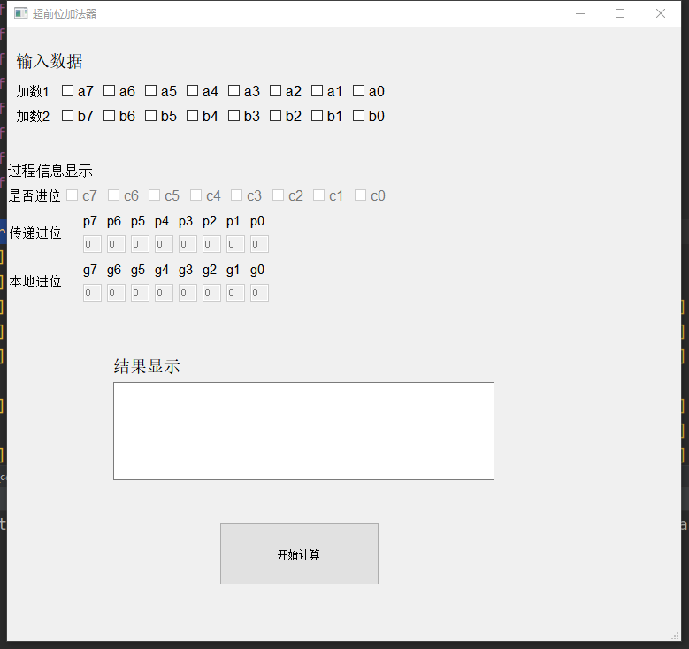

图3.1 系统主页

1. 勾选复选框，设置加数。如图3.2所示。

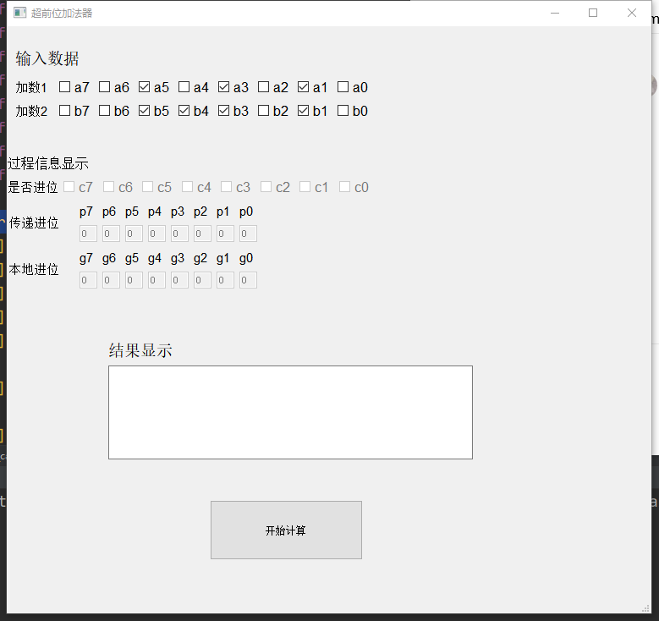

图3.2 选择加数

3.点击开始计算，获得计算结果以及中间结果。如图3.3所示。

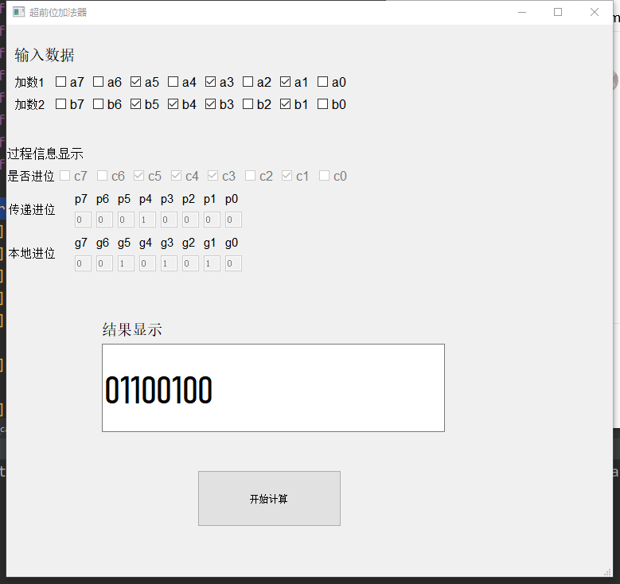

图3.3 计算结果

# 4 作品设计、实现难点分析

## 1.难点分析

一个项目的开发过程并不总是一帆风顺的，其中难免会遇到困难，使编程无法继续下去。例如最终打包为exe文件时，打包的exe文件无法使用，如下：

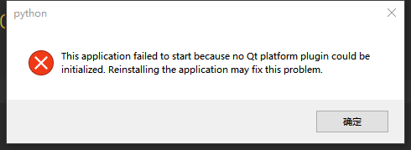

## 2.解决方案

针对程序设计过程中遇到的困难，我通过强大的网络资源，搜索了许多帖子，并且进行一一尝试，慢慢摸索，发现是python虚拟环境包含中文路径导致的，其实就是整个项目的名字设置成了中文，最终经过反复的调试及测试，解决了上述的难点，使得程序可以正常运转。

## 3.测试结果

程序在pycharm以及多台windows系统电脑中运行测试，能实现预期的功能，项目完工！

# 5 心得体会

通过本次设计8位超前进位加法器，我深入了解到了计算机原理的魅力，对于底层的操作，计算机到底是如何实现的哪？为什么普通的全加器可以实现加法的操作，人们还要设计超前进位加法器哪？4位、8位甚至16位超前进位加法器都有什么特点哪？通过本次实验设计，统统明白了这些问题，并且掌握了其中的道理，我相信这些基本的知识，无论在后续的课设中，还是今后对于计算机的学习，都起到了无可挑剔的作用。我也会继续学习相关的理论知识，为将来的学习、工作铺平道路。

# 6 参考文献

# 【1】董付国，python程序设计. 北京：清华大学出版社，2015.8

# 【2】张新荣，计算机组成原理.北京：机械工业出版社，2009.3 附录（源代码）

以下为主文件：

#!/usr/bin/env python

# -*- coding: utf-8 -*-

# @File : main.py

# @Project : 超前加法器

# @Software: PyCharm

# @Author : 大红昕

# @Time : 2020/6/16 17:21

from PyQt5.QtWidgets import QApplication, QMainWindow

import untitled

import sys

from PyQt5.QtCore import Qt

a = [0, 0, 0, 0, 0, 0, 0, 0]

b = [0, 0, 0, 0, 0, 0, 0, 0]

p = [0, 0, 0, 0, 0, 0, 0, 0]

g = [0, 0, 0, 0, 0, 0, 0, 0]

c = [0, 0, 0, 0, 0, 0, 0, 0]

s = [0, 0, 0, 0, 0, 0, 0, 0]

m = [0]

class MyWindow(QMainWindow):

def __init__(self):

super(MyWindow, self).__init__()

self.ui = untitled.Ui_MainWindow()

self.ui.setupUi(self)

self.ui.pushButton.clicked.connect(self.success_click_button)

def success_click_button(self):

self.is_chick()

self.progressive_calculate()

self.local_calculate()

self.carry_calculate()

self.res_calculate()

def is_chick(self):

"""

判断多选框中的值

:return:无

"""

if self.ui.a0.isChecked():

a[0] = 1

else:

a[0] = 0

if self.ui.a1.isChecked():

a[1] = 1

else:

a[1] = 0

if self.ui.a2.isChecked():

a[2] = 1

else:

a[2] = 0

if self.ui.a3.isChecked():

a[3] = 1

else:

a[3] = 0

if self.ui.a4.isChecked():

a[4] = 1

else:

a[4] = 0

if self.ui.a5.isChecked():

a[5] = 1

else:

a[5] = 0

if self.ui.a6.isChecked():

a[6] = 1

else:

a[6] = 0

if self.ui.a7.isChecked():

a[7] = 1

else:

a[7] = 0

if self.ui.b0.isChecked():

b[0] = 1

else:

b[0] = 0

if self.ui.b1.isChecked():

b[1] = 1

else:

b[1] = 0

if self.ui.b2.isChecked():

a[2] = 1

else:

b[2] = 0

if self.ui.b3.isChecked():

b[3] = 1

else:

b[3] = 0

if self.ui.b4.isChecked():

b[4] = 1

else:

b[4] = 0

if self.ui.b5.isChecked():

b[5] = 1

else:

b[5] = 0

if self.ui.b6.isChecked():

b[6] = 1

else:

b[6] = 0

if self.ui.b7.isChecked():

b[7] = 1

else:

b[7] = 0

def progressive_calculate(self):

"""

计算递进位并传参

:return: 无

"""

for key in range(len(p)):

p[key] = a[key] ^ b[key]

self.ui.lineEdit_p0.setText(str(p[0]))

self.ui.lineEdit_p1.setText(str(p[1]))

self.ui.lineEdit_p2.setText(str(p[2]))

self.ui.lineEdit_p3.setText(str(p[3]))

self.ui.lineEdit_p4.setText(str(p[4]))

self.ui.lineEdit_p5.setText(str(p[5]))

self.ui.lineEdit_p6.setText(str(p[6]))

self.ui.lineEdit_p7.setText(str(p[7]))

def local_calculate(self):

for key in range(len(g)):

g[key] = a[key] & b[key]

self.ui.lineEdit_g0.setText(str(g[0]))

self.ui.lineEdit_g1.setText(str(g[1]))

self.ui.lineEdit_g2.setText(str(g[2]))

self.ui.lineEdit_g3.setText(str(g[3]))

self.ui.lineEdit_g4.setText(str(g[4]))

self.ui.lineEdit_g5.setText(str(g[5]))

self.ui.lineEdit_g6.setText(str(g[6]))

self.ui.lineEdit_g7.setText(str(g[7]))

def carry_calculate(self):

c[0] = g[0] | p[0] & m[0];

c[1] = g[1] | p[1] & g[0] | p[1] & p[0] & m[0];

c[2] = g[2] | p[2] & g[1] | p[2] & p[1] & g[0] | p[2] & p[1] & p[0] & m[0];

c[3] = g[3] | p[3] & g[2] | p[3] & p[2] & g[1] | p[3] & p[2] & p[1] & g[0] | p[3] & p[2] & p[1] & p[0] & m[0]

c[4] = g[4] | p[4] & g[3] | p[4] & p[3] & g[2] | p[4] & p[3] & p[2] & g[1] | p[4] & p[3] & p[2] & p[1] & g[0] | \

p[4] & p[3] & p[2] & p[1] & p[0] & m[0]

c[5] = g[5] | p[5] & g[4] | p[5] & p[4] & g[3] | p[5] & p[4] & p[3] & g[2] | p[5] & p[4] & p[3] & p[2] & g[1] | \

p[5] & p[4] & p[3] & p[2] & p[1] & g[0] | p[5] & p[4] & p[3] & p[2] & p[1] & p[0] & m[0]

c[6] = g[6] | p[6] & g[5] | p[6] & p[5] & g[4] | p[6] & p[5] & p[4] & g[3] | p[6] & p[5] & p[4] & p[3] & g[2] | \

p[6] & p[5] & p[4] & p[3] & p[2] & g[1] | p[6] & p[5] & p[4] & p[3] & p[2] & p[1] & g[0] | p[6] & p[5] & \

p[4] & p[3] & p[2] & p[1] & p[0] & m[0]

c[7] = g[7] | p[7] & g[6] | p[7] & p[6] & g[5] | p[7] & p[6] & p[5] & g[4] | p[7] & p[6] & p[5] & p[4] & g[3] | \

p[7] & p[6] & p[5] & p[4] & p[3] & g[2] | p[7] & p[6] & p[5] & p[4] & p[3] & p[2] & g[1] | p[7] & p[6] & \

p[5] & p[4] & p[3] & p[2] & p[1] & g[0] | p[7] & p[6] & p[5] & p[4] & p[3] & p[2] & p[1] & p[0] & m[0]

self.ui.c0.setChecked(c[0])

self.ui.c1.setChecked(c[1])

self.ui.c2.setChecked(c[2])

self.ui.c3.setChecked(c[3])

self.ui.c4.setChecked(c[4])

self.ui.c5.setChecked(c[5])

self.ui.c6.setChecked(c[6])

self.ui.c7.setChecked(c[7])

def res_calculate(self):

res = ''

s[0] = (a[0] ^ b[0]) ^ m[0];

s[1] = (a[1] ^ b[1]) ^ ((a[0] & b[0]) | (a[0] ^ b[0]) & m[0]);

s[2] = (a[2] ^ b[2]) ^ ((a[1] & b[1]) | (a[1] ^ b[1]) & (a[0] & b[0]) | (a[1] ^ b[1]) & (a[0] & b[0]) & m[0]);

s[3] = (a[3] ^ b[3]) ^ (

(a[2] & b[2]) | (a[2] ^ b[2]) & (a[1] & b[1]) | (a[2] ^ b[2]) & (a[1] ^ b[1]) & (a[0] & b[0]) | (

a[2] ^ b[2]) & (a[1] ^ b[1]) & (

a[0] & b[0]) & m[0]);

s[4] = (a[4] ^ b[4]) ^ (

(a[3] & b[3]) | (a[3] ^ b[3]) & (a[2] & b[2]) | (a[3] ^ b[3]) & (a[2] ^ b[2]) & (a[1] & b[1]) | (

a[3] ^ b[3]) & (a[2] ^ b[2]) & (

a[1] ^ b[1]) & (a[0] & b[0]) | (a[3] ^ b[3]) & (a[2] ^ b[2]) & (a[1] ^ b[1]) & (a[0] ^ b[0]) &

m[0]);

s[5] = (a[5] ^ b[5]) ^ (

(a[4] & b[4]) | (a[4] ^ b[4]) & (a[3] & b[3]) | (a[4] ^ b[4]) & (a[3] ^ b[3]) & (a[2] & b[2]) | (

a[4] ^ b[4]) & (a[3] ^ b[3]) & (

a[2] ^ b[2]) & (a[1] & b[1]) | (a[4] ^ b[4]) & (a[3] ^ b[3]) & (a[2] ^ b[2]) & (a[1] ^ b[1]) & (

a[0] & b[0]) | (a[4] ^ b[4]) & (

a[3] ^ b[3]) & (a[2] ^ b[2]) & (a[1] ^ b[1]) & (a[0] ^ b[0]) & m[0]);

s[6] = (a[6] ^ b[6]) ^ (

(a[5] & b[5]) | (a[5] ^ b[5]) & (a[4] & b[4]) | (a[5] ^ b[5]) & (a[4] ^ b[4]) & (a[3] & b[3]) | (

a[5] ^ b[5]) & (a[4] ^ b[4]) & (

a[3] ^ b[3]) & (a[2] & b[2]) | (a[5] ^ b[5]) & (a[4] ^ b[4]) & (a[3] ^ b[3]) & (a[2] ^ b[2]) & (

a[1] & b[1]) | (a[5] ^ b[5]) & (

a[4] ^ b[4]) & (a[3] ^ b[3]) & (a[2] ^ b[2]) & (a[1] ^ b[1]) & (a[0] & b[0]) | (a[5] ^ b[5]) & (

a[4] ^ b[4]) & (

a[3] ^ b[3]) & (a[2] ^ b[2]) & (a[1] ^ b[1]) & (a[0] ^ b[0]) & m[0]);

s[7] = (a[7] ^ b[7]) ^ (

(a[6] & b[6]) | (a[6] ^ b[6]) & (a[5] & b[5]) | (a[6] ^ b[6]) & (a[5] ^ b[5]) & (a[4] & b[4]) | (

a[6] ^ b[6]) & (a[5] ^ b[5]) & (

a[4] ^ b[4]) & (a[3] & b[3]) | (a[6] ^ b[6]) & (a[5] ^ b[5]) & (a[4] ^ b[4]) & (a[3] ^ b[3]) & (

a[2] & b[2]) | (a[6] ^ b[6]) & (

a[5] ^ b[5]) & (a[4] ^ b[4]) & (a[3] ^ b[3]) & (a[2] ^ b[2]) & (a[1] & b[1]) | (a[6] ^ b[6]) & (

a[5] ^ b[5]) & (

a[4] ^ b[4]) & (a[3] ^ b[3]) & (a[2] ^ b[2]) & (a[1] ^ b[1]) & (a[0] & b[0]) | (a[6] ^ b[6]) & (

a[5] ^ b[5]) & (

a[4] ^ b[4]) & (a[3] ^ b[3]) & (a[2] ^ b[2]) & (a[1] ^ b[1]) & (a[0] ^ b[0]) & m[0]);

for i in s[::-1]:

res += str(i)

self.ui.lineEdit_result.setText(res)

if __name__ == "__main__":

app = QApplication(sys.argv)

show = MyWindow()

show.show()

sys.exit(app.exec_())

以下为UI界面代码：

# -*- coding: utf-8 -*-

# Form implementation generated from reading ui file 'untitled.ui'

#

# Created by: PyQt5 UI code generator 5.13.2

#

# WARNING! All changes made in this file will be lost!

from PyQt5 import QtCore, QtGui, QtWidgets

class Ui_MainWindow(object):

def setupUi(self, MainWindow):

MainWindow.setObjectName("MainWindow")

MainWindow.resize(762, 694)

MainWindow.setStyleSheet("")

self.centralwidget = QtWidgets.QWidget(MainWindow)

self.centralwidget.setObjectName("centralwidget")

self.layoutWidget = QtWidgets.QWidget(self.centralwidget)

self.layoutWidget.setGeometry(QtCore.QRect(10, 20, 422, 91))

self.layoutWidget.setObjectName("layoutWidget")

self.verticalLayout_2 = QtWidgets.QVBoxLayout(self.layoutWidget)

self.verticalLayout_2.setContentsMargins(0, 0, 0, 0)

self.verticalLayout_2.setObjectName("verticalLayout_2")

self.label_6 = QtWidgets.QLabel(self.layoutWidget)

self.label_6.setStyleSheet("font: 25 14pt \"Bahnschrift Light\";")

self.label_6.setObjectName("label_6")

self.verticalLayout_2.addWidget(self.label_6)

self.verticalLayout = QtWidgets.QVBoxLayout()

self.verticalLayout.setObjectName("verticalLayout")

self.horizontalLayout_2 = QtWidgets.QHBoxLayout()

self.horizontalLayout_2.setObjectName("horizontalLayout_2")

self.label = QtWidgets.QLabel(self.layoutWidget)

self.label.setStyleSheet("font: 11pt \"Arial\";")

self.label.setObjectName("label")

self.horizontalLayout_2.addWidget(self.label)

self.horizontalLayout = QtWidgets.QHBoxLayout()

self.horizontalLayout.setObjectName("horizontalLayout")

self.a7 = QtWidgets.QCheckBox(self.layoutWidget)

self.a7.setStyleSheet("font: 12pt \"Arial\";")

self.a7.setObjectName("a7")

self.horizontalLayout.addWidget(self.a7)

self.a6 = QtWidgets.QCheckBox(self.layoutWidget)

self.a6.setStyleSheet("font: 12pt \"Arial\";")

self.a6.setObjectName("a6")

self.horizontalLayout.addWidget(self.a6)

self.a5 = QtWidgets.QCheckBox(self.layoutWidget)

self.a5.setStyleSheet("font: 12pt \"Arial\";")

self.a5.setObjectName("a5")

self.horizontalLayout.addWidget(self.a5)

self.a4 = QtWidgets.QCheckBox(self.layoutWidget)

self.a4.setStyleSheet("font: 12pt \"Arial\";")

self.a4.setObjectName("a4")

self.horizontalLayout.addWidget(self.a4)

self.a3 = QtWidgets.QCheckBox(self.layoutWidget)

self.a3.setStyleSheet("font: 12pt \"Arial\";")

self.a3.setObjectName("a3")

self.horizontalLayout.addWidget(self.a3)

self.a2 = QtWidgets.QCheckBox(self.layoutWidget)

self.a2.setStyleSheet("font: 12pt \"Arial\";")

self.a2.setObjectName("a2")

self.horizontalLayout.addWidget(self.a2)

self.a1 = QtWidgets.QCheckBox(self.layoutWidget)

self.a1.setStyleSheet("font: 12pt \"Arial\";")

self.a1.setObjectName("a1")

self.horizontalLayout.addWidget(self.a1)

self.a0 = QtWidgets.QCheckBox(self.layoutWidget)

self.a0.setStyleSheet("font: 12pt \"Arial\";")

self.a0.setObjectName("a0")

self.horizontalLayout.addWidget(self.a0)

self.horizontalLayout_2.addLayout(self.horizontalLayout)

self.verticalLayout.addLayout(self.horizontalLayout_2)

self.horizontalLayout_5 = QtWidgets.QHBoxLayout()

self.horizontalLayout_5.setObjectName("horizontalLayout_5")

self.label_3 = QtWidgets.QLabel(self.layoutWidget)

self.label_3.setStyleSheet("font: 11pt \"Arial\";")

self.label_3.setObjectName("label_3")

self.horizontalLayout_5.addWidget(self.label_3)

self.horizontalLayout_6 = QtWidgets.QHBoxLayout()

self.horizontalLayout_6.setObjectName("horizontalLayout_6")

self.b7 = QtWidgets.QCheckBox(self.layoutWidget)

self.b7.setStyleSheet("font: 12pt \"Arial\";")

self.b7.setObjectName("b7")

self.horizontalLayout_6.addWidget(self.b7)

self.b6 = QtWidgets.QCheckBox(self.layoutWidget)

self.b6.setStyleSheet("font: 12pt \"Arial\";")

self.b6.setObjectName("b6")

self.horizontalLayout_6.addWidget(self.b6)

self.b5 = QtWidgets.QCheckBox(self.layoutWidget)

self.b5.setStyleSheet("font: 12pt \"Arial\";")

self.b5.setObjectName("b5")

self.horizontalLayout_6.addWidget(self.b5)

self.b4 = QtWidgets.QCheckBox(self.layoutWidget)

self.b4.setStyleSheet("font: 12pt \"Arial\";")

self.b4.setObjectName("b4")

self.horizontalLayout_6.addWidget(self.b4)

self.b3 = QtWidgets.QCheckBox(self.layoutWidget)

self.b3.setStyleSheet("font: 12pt \"Arial\";")

self.b3.setObjectName("b3")

self.horizontalLayout_6.addWidget(self.b3)

self.b2 = QtWidgets.QCheckBox(self.layoutWidget)

self.b2.setStyleSheet("font: 12pt \"Arial\";")

self.b2.setObjectName("b2")

self.horizontalLayout_6.addWidget(self.b2)

self.b1 = QtWidgets.QCheckBox(self.layoutWidget)

self.b1.setStyleSheet("font: 12pt \"Arial\";")

self.b1.setObjectName("b1")

self.horizontalLayout_6.addWidget(self.b1)

self.b0 = QtWidgets.QCheckBox(self.layoutWidget)

self.b0.setStyleSheet("font: 12pt \"Arial\";")

self.b0.setObjectName("b0")

self.horizontalLayout_6.addWidget(self.b0)

self.horizontalLayout_5.addLayout(self.horizontalLayout_6)

self.verticalLayout.addLayout(self.horizontalLayout_5)

self.verticalLayout_2.addLayout(self.verticalLayout)

self.pushButton = QtWidgets.QPushButton(self.centralwidget)

self.pushButton.setGeometry(QtCore.QRect(240, 560, 181, 71))

self.pushButton.setObjectName("pushButton")

self.label_4 = QtWidgets.QLabel(self.centralwidget)

self.label_4.setGeometry(QtCore.QRect(450, 720, 121, 31))

self.label_4.setObjectName("label_4")

self.layoutWidget1 = QtWidgets.QWidget(self.centralwidget)

self.layoutWidget1.setGeometry(QtCore.QRect(2, 263, 294, 47))

self.layoutWidget1.setObjectName("layoutWidget1")

self.horizontalLayout_3 = QtWidgets.QHBoxLayout(self.layoutWidget1)

self.horizontalLayout_3.setContentsMargins(0, 0, 0, 0)

self.horizontalLayout_3.setObjectName("horizontalLayout_3")

self.label_8 = QtWidgets.QLabel(self.layoutWidget1)

self.label_8.setStyleSheet("font: 25 11pt \"Bahnschrift Light\";")

self.label_8.setObjectName("label_8")

self.horizontalLayout_3.addWidget(self.label_8)

self.verticalLayout_18 = QtWidgets.QVBoxLayout()

self.verticalLayout_18.setObjectName("verticalLayout_18")

self.label_17 = QtWidgets.QLabel(self.layoutWidget1)

self.label_17.setMaximumSize(QtCore.QSize(16, 16777215))

self.label_17.setStyleSheet("font: 11pt \"Arial\";")

self.label_17.setObjectName("label_17")

self.verticalLayout_18.addWidget(self.label_17)

self.lineEdit_g7 = QtWidgets.QLineEdit(self.layoutWidget1)

self.lineEdit_g7.setEnabled(False)

self.lineEdit_g7.setMaximumSize(QtCore.QSize(21, 16777215))

self.lineEdit_g7.setObjectName("lineEdit_g7")

self.verticalLayout_18.addWidget(self.lineEdit_g7)

self.horizontalLayout_3.addLayout(self.verticalLayout_18)

self.verticalLayout_17 = QtWidgets.QVBoxLayout()

self.verticalLayout_17.setObjectName("verticalLayout_17")

self.label_18 = QtWidgets.QLabel(self.layoutWidget1)

self.label_18.setMaximumSize(QtCore.QSize(16, 16777215))

self.label_18.setStyleSheet("font: 11pt \"Arial\";")

self.label_18.setObjectName("label_18")

self.verticalLayout_17.addWidget(self.label_18)

self.lineEdit_g6 = QtWidgets.QLineEdit(self.layoutWidget1)

self.lineEdit_g6.setEnabled(False)

self.lineEdit_g6.setMaximumSize(QtCore.QSize(21, 16777215))

self.lineEdit_g6.setObjectName("lineEdit_g6")

self.verticalLayout_17.addWidget(self.lineEdit_g6)

self.horizontalLayout_3.addLayout(self.verticalLayout_17)

self.verticalLayout_16 = QtWidgets.QVBoxLayout()

self.verticalLayout_16.setObjectName("verticalLayout_16")

self.label_19 = QtWidgets.QLabel(self.layoutWidget1)

self.label_19.setMaximumSize(QtCore.QSize(16, 16777215))

self.label_19.setStyleSheet("font: 11pt \"Arial\";")

self.label_19.setObjectName("label_19")

self.verticalLayout_16.addWidget(self.label_19)

self.lineEdit_g5 = QtWidgets.QLineEdit(self.layoutWidget1)

self.lineEdit_g5.setEnabled(False)

self.lineEdit_g5.setMaximumSize(QtCore.QSize(21, 16777215))

self.lineEdit_g5.setObjectName("lineEdit_g5")

self.verticalLayout_16.addWidget(self.lineEdit_g5)

self.horizontalLayout_3.addLayout(self.verticalLayout_16)

self.verticalLayout_15 = QtWidgets.QVBoxLayout()

self.verticalLayout_15.setObjectName("verticalLayout_15")

self.label_20 = QtWidgets.QLabel(self.layoutWidget1)

self.label_20.setMaximumSize(QtCore.QSize(16, 16777215))

self.label_20.setStyleSheet("font: 11pt \"Arial\";")

self.label_20.setObjectName("label_20")

self.verticalLayout_15.addWidget(self.label_20)

self.lineEdit_g4 = QtWidgets.QLineEdit(self.layoutWidget1)

self.lineEdit_g4.setEnabled(False)

self.lineEdit_g4.setMaximumSize(QtCore.QSize(21, 16777215))

self.lineEdit_g4.setObjectName("lineEdit_g4")

self.verticalLayout_15.addWidget(self.lineEdit_g4)

self.horizontalLayout_3.addLayout(self.verticalLayout_15)

self.verticalLayout_14 = QtWidgets.QVBoxLayout()

self.verticalLayout_14.setObjectName("verticalLayout_14")

self.label_21 = QtWidgets.QLabel(self.layoutWidget1)

self.label_21.setMaximumSize(QtCore.QSize(16, 16777215))

self.label_21.setStyleSheet("font: 11pt \"Arial\";")

self.label_21.setObjectName("label_21")

self.verticalLayout_14.addWidget(self.label_21)

self.lineEdit_g3 = QtWidgets.QLineEdit(self.layoutWidget1)

self.lineEdit_g3.setEnabled(False)

self.lineEdit_g3.setMaximumSize(QtCore.QSize(21, 16777215))

self.lineEdit_g3.setObjectName("lineEdit_g3")

self.verticalLayout_14.addWidget(self.lineEdit_g3)

self.horizontalLayout_3.addLayout(self.verticalLayout_14)

self.verticalLayout_13 = QtWidgets.QVBoxLayout()

self.verticalLayout_13.setObjectName("verticalLayout_13")

self.label_22 = QtWidgets.QLabel(self.layoutWidget1)

self.label_22.setMaximumSize(QtCore.QSize(16, 16777215))

self.label_22.setStyleSheet("font: 11pt \"Arial\";")

self.label_22.setObjectName("label_22")

self.verticalLayout_13.addWidget(self.label_22)

self.lineEdit_g2 = QtWidgets.QLineEdit(self.layoutWidget1)

self.lineEdit_g2.setEnabled(False)

self.lineEdit_g2.setMaximumSize(QtCore.QSize(21, 16777215))

self.lineEdit_g2.setObjectName("lineEdit_g2")

self.verticalLayout_13.addWidget(self.lineEdit_g2)

self.horizontalLayout_3.addLayout(self.verticalLayout_13)

self.verticalLayout_12 = QtWidgets.QVBoxLayout()

self.verticalLayout_12.setObjectName("verticalLayout_12")

self.label_23 = QtWidgets.QLabel(self.layoutWidget1)

self.label_23.setMaximumSize(QtCore.QSize(16, 16777215))

self.label_23.setStyleSheet("font: 11pt \"Arial\";")

self.label_23.setObjectName("label_23")

self.verticalLayout_12.addWidget(self.label_23)

self.lineEdit_g1 = QtWidgets.QLineEdit(self.layoutWidget1)

self.lineEdit_g1.setEnabled(False)

self.lineEdit_g1.setMaximumSize(QtCore.QSize(21, 16777215))

self.lineEdit_g1.setObjectName("lineEdit_g1")

self.verticalLayout_12.addWidget(self.lineEdit_g1)

self.horizontalLayout_3.addLayout(self.verticalLayout_12)

self.verticalLayout_11 = QtWidgets.QVBoxLayout()

self.verticalLayout_11.setObjectName("verticalLayout_11")

self.label_24 = QtWidgets.QLabel(self.layoutWidget1)

self.label_24.setMaximumSize(QtCore.QSize(16, 16777215))

self.label_24.setStyleSheet("font: 11pt \"Arial\";")

self.label_24.setObjectName("label_24")

self.verticalLayout_11.addWidget(self.label_24)

self.lineEdit_g0 = QtWidgets.QLineEdit(self.layoutWidget1)

self.lineEdit_g0.setEnabled(False)

self.lineEdit_g0.setMaximumSize(QtCore.QSize(21, 16777215))

self.lineEdit_g0.setObjectName("lineEdit_g0")

self.verticalLayout_11.addWidget(self.lineEdit_g0)

self.horizontalLayout_3.addLayout(self.verticalLayout_11)

self.layoutWidget2 = QtWidgets.QWidget(self.centralwidget)

self.layoutWidget2.setGeometry(QtCore.QRect(2, 208, 294, 47))

self.layoutWidget2.setObjectName("layoutWidget2")

self.horizontalLayout_4 = QtWidgets.QHBoxLayout(self.layoutWidget2)

self.horizontalLayout_4.setContentsMargins(0, 0, 0, 0)

self.horizontalLayout_4.setObjectName("horizontalLayout_4")

self.label_7 = QtWidgets.QLabel(self.layoutWidget2)

self.label_7.setStyleSheet("font: 25 11pt \"Bahnschrift Light\";")

self.label_7.setObjectName("label_7")

self.horizontalLayout_4.addWidget(self.label_7)

self.verticalLayout_3 = QtWidgets.QVBoxLayout()

self.verticalLayout_3.setObjectName("verticalLayout_3")

self.label_9 = QtWidgets.QLabel(self.layoutWidget2)

self.label_9.setMaximumSize(QtCore.QSize(16, 16777215))

self.label_9.setStyleSheet("font: 11pt \"Arial\";")

self.label_9.setObjectName("label_9")

self.verticalLayout_3.addWidget(self.label_9)

self.lineEdit_p7 = QtWidgets.QLineEdit(self.layoutWidget2)

self.lineEdit_p7.setEnabled(False)

self.lineEdit_p7.setMaximumSize(QtCore.QSize(21, 16777215))

self.lineEdit_p7.setObjectName("lineEdit_p7")

self.verticalLayout_3.addWidget(self.lineEdit_p7)

self.horizontalLayout_4.addLayout(self.verticalLayout_3)

self.verticalLayout_4 = QtWidgets.QVBoxLayout()

self.verticalLayout_4.setObjectName("verticalLayout_4")

self.label_10 = QtWidgets.QLabel(self.layoutWidget2)

self.label_10.setMaximumSize(QtCore.QSize(16, 16777215))

self.label_10.setStyleSheet("font: 11pt \"Arial\";")

self.label_10.setObjectName("label_10")

self.verticalLayout_4.addWidget(self.label_10)

self.lineEdit_p6 = QtWidgets.QLineEdit(self.layoutWidget2)

self.lineEdit_p6.setEnabled(False)

self.lineEdit_p6.setMaximumSize(QtCore.QSize(21, 16777215))

self.lineEdit_p6.setObjectName("lineEdit_p6")

self.verticalLayout_4.addWidget(self.lineEdit_p6)

self.horizontalLayout_4.addLayout(self.verticalLayout_4)

self.verticalLayout_5 = QtWidgets.QVBoxLayout()

self.verticalLayout_5.setObjectName("verticalLayout_5")

self.label_11 = QtWidgets.QLabel(self.layoutWidget2)

self.label_11.setMaximumSize(QtCore.QSize(16, 16777215))

self.label_11.setStyleSheet("font: 11pt \"Arial\";")

self.label_11.setObjectName("label_11")

self.verticalLayout_5.addWidget(self.label_11)

self.lineEdit_p5 = QtWidgets.QLineEdit(self.layoutWidget2)

self.lineEdit_p5.setEnabled(False)

self.lineEdit_p5.setMaximumSize(QtCore.QSize(21, 16777215))

self.lineEdit_p5.setObjectName("lineEdit_p5")

self.verticalLayout_5.addWidget(self.lineEdit_p5)

self.horizontalLayout_4.addLayout(self.verticalLayout_5)

self.verticalLayout_6 = QtWidgets.QVBoxLayout()

self.verticalLayout_6.setObjectName("verticalLayout_6")

self.label_12 = QtWidgets.QLabel(self.layoutWidget2)

self.label_12.setMaximumSize(QtCore.QSize(16, 16777215))

self.label_12.setStyleSheet("font: 11pt \"Arial\";")

self.label_12.setObjectName("label_12")

self.verticalLayout_6.addWidget(self.label_12)

self.lineEdit_p4 = QtWidgets.QLineEdit(self.layoutWidget2)

self.lineEdit_p4.setEnabled(False)

self.lineEdit_p4.setMaximumSize(QtCore.QSize(21, 16777215))

self.lineEdit_p4.setObjectName("lineEdit_p4")

self.verticalLayout_6.addWidget(self.lineEdit_p4)

self.horizontalLayout_4.addLayout(self.verticalLayout_6)

self.verticalLayout_7 = QtWidgets.QVBoxLayout()

self.verticalLayout_7.setObjectName("verticalLayout_7")

self.label_13 = QtWidgets.QLabel(self.layoutWidget2)

self.label_13.setMaximumSize(QtCore.QSize(16, 16777215))

self.label_13.setStyleSheet("font: 11pt \"Arial\";")

self.label_13.setObjectName("label_13")

self.verticalLayout_7.addWidget(self.label_13)

self.lineEdit_p3 = QtWidgets.QLineEdit(self.layoutWidget2)

self.lineEdit_p3.setEnabled(False)

self.lineEdit_p3.setMaximumSize(QtCore.QSize(21, 16777215))

self.lineEdit_p3.setObjectName("lineEdit_p3")

self.verticalLayout_7.addWidget(self.lineEdit_p3)

self.horizontalLayout_4.addLayout(self.verticalLayout_7)

self.verticalLayout_8 = QtWidgets.QVBoxLayout()

self.verticalLayout_8.setObjectName("verticalLayout_8")

self.label_14 = QtWidgets.QLabel(self.layoutWidget2)

self.label_14.setMaximumSize(QtCore.QSize(16, 16777215))

self.label_14.setStyleSheet("font: 11pt \"Arial\";")

self.label_14.setObjectName("label_14")

self.verticalLayout_8.addWidget(self.label_14)

self.lineEdit_p2 = QtWidgets.QLineEdit(self.layoutWidget2)

self.lineEdit_p2.setEnabled(False)

self.lineEdit_p2.setMaximumSize(QtCore.QSize(21, 16777215))

self.lineEdit_p2.setObjectName("lineEdit_p2")

self.verticalLayout_8.addWidget(self.lineEdit_p2)

self.horizontalLayout_4.addLayout(self.verticalLayout_8)

self.verticalLayout_9 = QtWidgets.QVBoxLayout()

self.verticalLayout_9.setObjectName("verticalLayout_9")

self.label_15 = QtWidgets.QLabel(self.layoutWidget2)

self.label_15.setMaximumSize(QtCore.QSize(16, 16777215))

self.label_15.setStyleSheet("font: 11pt \"Arial\";")

self.label_15.setObjectName("label_15")

self.verticalLayout_9.addWidget(self.label_15)

self.lineEdit_p1 = QtWidgets.QLineEdit(self.layoutWidget2)

self.lineEdit_p1.setEnabled(False)

self.lineEdit_p1.setMaximumSize(QtCore.QSize(21, 16777215))

self.lineEdit_p1.setObjectName("lineEdit_p1")

self.verticalLayout_9.addWidget(self.lineEdit_p1)

self.horizontalLayout_4.addLayout(self.verticalLayout_9)

self.verticalLayout_10 = QtWidgets.QVBoxLayout()

self.verticalLayout_10.setObjectName("verticalLayout_10")

self.label_16 = QtWidgets.QLabel(self.layoutWidget2)

self.label_16.setMaximumSize(QtCore.QSize(16, 16777215))

self.label_16.setStyleSheet("font: 11pt \"Arial\";")

self.label_16.setObjectName("label_16")

self.verticalLayout_10.addWidget(self.label_16)

self.lineEdit_p0 = QtWidgets.QLineEdit(self.layoutWidget2)

self.lineEdit_p0.setEnabled(False)

self.lineEdit_p0.setMaximumSize(QtCore.QSize(21, 16777215))

self.lineEdit_p0.setObjectName("lineEdit_p0")

self.verticalLayout_10.addWidget(self.lineEdit_p0)

self.horizontalLayout_4.addLayout(self.verticalLayout_10)

self.layoutWidget3 = QtWidgets.QWidget(self.centralwidget)

self.layoutWidget3.setGeometry(QtCore.QRect(1, 151, 432, 50))

self.layoutWidget3.setObjectName("layoutWidget3")

self.verticalLayout_19 = QtWidgets.QVBoxLayout(self.layoutWidget3)

self.verticalLayout_19.setContentsMargins(0, 0, 0, 0)

self.verticalLayout_19.setObjectName("verticalLayout_19")

self.label_25 = QtWidgets.QLabel(self.layoutWidget3)

self.label_25.setStyleSheet("font: 12pt \"Arial\";")

self.label_25.setObjectName("label_25")

self.verticalLayout_19.addWidget(self.label_25)

self.horizontalLayout_7 = QtWidgets.QHBoxLayout()

self.horizontalLayout_7.setObjectName("horizontalLayout_7")

self.label_5 = QtWidgets.QLabel(self.layoutWidget3)

self.label_5.setStyleSheet("font: 11pt \"Arial\";")

self.label_5.setObjectName("label_5")

self.horizontalLayout_7.addWidget(self.label_5)

self.c7 = QtWidgets.QCheckBox(self.layoutWidget3)

self.c7.setEnabled(False)

self.c7.setStyleSheet("font: 12pt \"Arial\";")

self.c7.setObjectName("c7")

self.horizontalLayout_7.addWidget(self.c7)

self.c6 = QtWidgets.QCheckBox(self.layoutWidget3)

self.c6.setEnabled(False)

self.c6.setStyleSheet("font: 12pt \"Arial\";")

self.c6.setObjectName("c6")

self.horizontalLayout_7.addWidget(self.c6)

self.c5 = QtWidgets.QCheckBox(self.layoutWidget3)

self.c5.setEnabled(False)

self.c5.setStyleSheet("font: 12pt \"Arial\";")

self.c5.setObjectName("c5")

self.horizontalLayout_7.addWidget(self.c5)

self.c4 = QtWidgets.QCheckBox(self.layoutWidget3)

self.c4.setEnabled(False)

self.c4.setStyleSheet("font: 12pt \"Arial\";")

self.c4.setObjectName("c4")

self.horizontalLayout_7.addWidget(self.c4)

self.c3 = QtWidgets.QCheckBox(self.layoutWidget3)

self.c3.setEnabled(False)

self.c3.setStyleSheet("font: 12pt \"Arial\";")

self.c3.setObjectName("c3")

self.horizontalLayout_7.addWidget(self.c3)

self.c2 = QtWidgets.QCheckBox(self.layoutWidget3)

self.c2.setEnabled(False)

self.c2.setStyleSheet("font: 12pt \"Arial\";")

self.c2.setObjectName("c2")

self.horizontalLayout_7.addWidget(self.c2)

self.c1 = QtWidgets.QCheckBox(self.layoutWidget3)

self.c1.setEnabled(False)

self.c1.setStyleSheet("font: 12pt \"Arial\";")

self.c1.setObjectName("c1")

self.horizontalLayout_7.addWidget(self.c1)

self.c0 = QtWidgets.QCheckBox(self.layoutWidget3)

self.c0.setEnabled(False)

self.c0.setStyleSheet("font: 12pt \"Arial\";")

self.c0.setObjectName("c0")

self.horizontalLayout_7.addWidget(self.c0)

self.verticalLayout_19.addLayout(self.horizontalLayout_7)

self.layoutWidget4 = QtWidgets.QWidget(self.centralwidget)

self.layoutWidget4.setGeometry(QtCore.QRect(120, 370, 433, 142))

self.layoutWidget4.setObjectName("layoutWidget4")

self.verticalLayout_20 = QtWidgets.QVBoxLayout(self.layoutWidget4)

self.verticalLayout_20.setContentsMargins(0, 0, 0, 0)

self.verticalLayout_20.setObjectName("verticalLayout_20")

self.label_2 = QtWidgets.QLabel(self.layoutWidget4)

self.label_2.setStyleSheet("font: 25 14pt \"Bahnschrift Light\";")

self.label_2.setObjectName("label_2")

self.verticalLayout_20.addWidget(self.label_2)

self.lineEdit_result = QtWidgets.QLineEdit(self.layoutWidget4)

self.lineEdit_result.setMinimumSize(QtCore.QSize(431, 111))

self.lineEdit_result.setMaximumSize(QtCore.QSize(431, 16777215))

self.lineEdit_result.setStyleSheet("font: 36pt \"Bahnschrift SemiLight Condensed\";\n"

"")

self.lineEdit_result.setText("")

self.lineEdit_result.setObjectName("lineEdit_result")

self.verticalLayout_20.addWidget(self.lineEdit_result)

MainWindow.setCentralWidget(self.centralwidget)

self.statusbar = QtWidgets.QStatusBar(MainWindow)

self.statusbar.setObjectName("statusbar")

MainWindow.setStatusBar(self.statusbar)

self.retranslateUi(MainWindow)

QtCore.QMetaObject.connectSlotsByName(MainWindow)

def retranslateUi(self, MainWindow):

_translate = QtCore.QCoreApplication.translate

MainWindow.setWindowTitle(_translate("MainWindow", "超前位加法器"))

self.label_6.setText(_translate("MainWindow", "输入数据"))

self.label.setText(_translate("MainWindow", "加数1"))

self.a7.setText(_translate("MainWindow", "a7"))

self.a6.setText(_translate("MainWindow", "a6"))

self.a5.setText(_translate("MainWindow", "a5"))

self.a4.setText(_translate("MainWindow", "a4"))

self.a3.setText(_translate("MainWindow", "a3"))

self.a2.setText(_translate("MainWindow", "a2"))

self.a1.setText(_translate("MainWindow", "a1"))

self.a0.setText(_translate("MainWindow", "a0"))

self.label_3.setText(_translate("MainWindow", "加数2"))

self.b7.setText(_translate("MainWindow", "b7"))

self.b6.setText(_translate("MainWindow", "b6"))

self.b5.setText(_translate("MainWindow", "b5"))

self.b4.setText(_translate("MainWindow", "b4"))

self.b3.setText(_translate("MainWindow", "b3"))

self.b2.setText(_translate("MainWindow", "b2"))

self.b1.setText(_translate("MainWindow", "b1"))

self.b0.setText(_translate("MainWindow", "b0"))

self.pushButton.setText(_translate("MainWindow", "开始计算"))

self.label_4.setText(_translate("MainWindow", "华北理工大学--马昕"))

self.label_8.setText(_translate("MainWindow", "本地进位"))

self.label_17.setText(_translate("MainWindow", "g7"))

self.lineEdit_g7.setText(_translate("MainWindow", "0"))

self.label_18.setText(_translate("MainWindow", "g6"))

self.lineEdit_g6.setText(_translate("MainWindow", "0"))

self.label_19.setText(_translate("MainWindow", "g5"))

self.lineEdit_g5.setText(_translate("MainWindow", "0"))

self.label_20.setText(_translate("MainWindow", "g4"))

self.lineEdit_g4.setText(_translate("MainWindow", "0"))

self.label_21.setText(_translate("MainWindow", "g3"))

self.lineEdit_g3.setText(_translate("MainWindow", "0"))

self.label_22.setText(_translate("MainWindow", "g2"))

self.lineEdit_g2.setText(_translate("MainWindow", "0"))

self.label_23.setText(_translate("MainWindow", "g1"))

self.lineEdit_g1.setText(_translate("MainWindow", "0"))

self.label_24.setText(_translate("MainWindow", "g0"))

self.lineEdit_g0.setText(_translate("MainWindow", "0"))

self.label_7.setText(_translate("MainWindow", "传递进位"))

self.label_9.setText(_translate("MainWindow", "p7"))

self.lineEdit_p7.setText(_translate("MainWindow", "0"))

self.label_10.setText(_translate("MainWindow", "p6"))

self.lineEdit_p6.setText(_translate("MainWindow", "0"))

self.label_11.setText(_translate("MainWindow", "p5"))

self.lineEdit_p5.setText(_translate("MainWindow", "0"))

self.label_12.setText(_translate("MainWindow", "p4"))

self.lineEdit_p4.setText(_translate("MainWindow", "0"))

self.label_13.setText(_translate("MainWindow", "p3"))

self.lineEdit_p3.setText(_translate("MainWindow", "0"))

self.label_14.setText(_translate("MainWindow", "p2"))

self.lineEdit_p2.setText(_translate("MainWindow", "0"))

self.label_15.setText(_translate("MainWindow", "p1"))

self.lineEdit_p1.setText(_translate("MainWindow", "0"))

self.label_16.setText(_translate("MainWindow", "p0"))

self.lineEdit_p0.setText(_translate("MainWindow", "0"))

self.label_25.setText(_translate("MainWindow", "过程信息显示"))

self.label_5.setText(_translate("MainWindow", "是否进位"))

self.c7.setText(_translate("MainWindow", "c7"))

self.c6.setText(_translate("MainWindow", "c6"))

self.c5.setText(_translate("MainWindow", "c5"))

self.c4.setText(_translate("MainWindow", "c4"))

self.c3.setText(_translate("MainWindow", "c3"))

self.c2.setText(_translate("MainWindow", "c2"))

self.c1.setText(_translate("MainWindow", "c1"))

self.c0.setText(_translate("MainWindow", "c0"))

self.label_2.setText(_translate("MainWindow", "结果显示"))